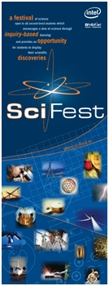
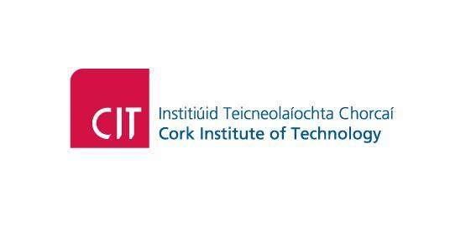

SciFest 2011

PROGRAMME
8.30  9.30  10.00  12.00  1.00 p.m.  1.30 p.m.  2.30 p.m.  3.15 p.m. | Registration and Set-up in the Nexus  Opening Ceremony by Mr Seán Sherlock, TD,  Minister for Research & Innovation  Judging Commences  Lunch for Competitors & Teachers  Science Talks:  Dr Hugh McGlynn - Science in CIT  Dr Siobhán O’Sullivan – Cracking the Code The Story of DNA  Science Show – Mr Tony Galvin  Prize Giving Ceremony  Closing Ceremony

